Assembling the adapter board
Original directions by Ryan Nimick
Revised by DIYAutoTune.com for V0.05 board

The first step to assembling the megasquirt to motronic 55pin board will be to source an old ecu. It won’t matter if it has water damage or not so you can usually source one from a junk yard for less than $75. Just make sure that the plastic connector is in good shape and the mounting plate fits your vehicle. The single board design such as the 173/179 ECUs are more desirable as they will solder straight to the new board with little work but the older dual board design will work if need be.

Next you need to disassemble the ECU. First remove the top cover by unbending all 10 of the tabs on the back side. The cover should lift free. Remove all 6 screws from the bottom and the connector and board will come free from the aluminum backing. Now that the board is exposed, we will remove the connector. Keep in mind the connector and pins are all we are trying to save here. If you look on the bottom of the board, there will be what looks like 2 black rivets on either side of the 55 pins that go to the connector. These are the structural mounting points between the PCB and 55pin connector. The easiest and most effective way to remove them is to grind off the posterior surface with an angle grinder being careful not to go past the first layer of the rivet and avoid any of the 55 pins.

Next you will separate the solder joints that join the PCB and 55pin connector. This can be accomplished in two ways. The preferred method is to use a solder pump to remove all of the solder form the joints and carefully remove the connector. This may not be the most practical method though, being that a good solder pump runs upwards of $1000. Another method is to secure the plastic connector in a vice or similar clamp so that almost non of the plastic is showing and use a heat gun on the back of the board to heat all of the joints to pry the PCB from the connector. You must be very careful not to bend the pins too much and be sure to use a good, high temp heat gun. My first attempt with this method was with a cheaper hobby grade gun that couldn’t quite heat the joints enough and bent several of the pins severely. I later found a good industrial heat gun that did a much better job at liquefying the solder. After you have heated the solder on one side to the point that you can see it liquefy, gently start to rock the board back and forth and side to side. If need be, you can use a screw driver to get some leverage from the back side. Just remember to take your time. The board should also start to get soft and pliable. This is very advantageous, as it will allow you to remove the pins in one small section at a time. Start at one side and move down the row pulling the board free of the pins as you go.

After the board has been freed of the connector, some debris from the board may still be on the pins. You can continue to use your heat gun and a wire brush to remove this or you can use your soldering iron and solder wick. Once this has been done, examine the pins and make sure none of them are bent out of place too far. Remember that you have to get all 55 of these to line up at the same time.

Now that the hard part it done you can get down to business. Install the connector to the MS adapter board and make sure it is fully seated. If you can’t get it to stay lined up, you can reinstall the bolts the go through the rivets you partially ground off or have another set of hands around. Either way, make sure the connector is at 90 degrees with the board and solder all 55 joints on the adapter board.

Next you will install all of the electrical components. I like to start with the most difficult part first. Remove all 6 2n2222a transistors (Q0-5) from the bag and mount them to the board. Make sure they are slightly raised from the board. There should be notches on the legs of the transistors to hold them at the proper height.

Next you will need to install all of the diodes (D1-8). They are all the same but are one way components. You must pay attention to the orientation when installing them or the circuit will not function properly and the Megasquirt could be damaged. There will be a banded end on the diode and a banded end of the silkscreen image of the component. Simply line them up.

Next, install all of the resistors. Note that not all of them are necessary if you don’t want some of the add-on options. Ign B and C and R13-14 are for using wasted spark coils and are not needed if you intend to use the stock coil and distributor. The boost driver and R11-12 are for use with the boost control circuit and are not necessary otherwise. Some of the other components may not be absolutely necessary but are cheap enough that it would be pointless to exclude them.

Now install the DB connectors U1 and U3. They should snap into place and are easily soldered from the back side.

Before you continue, you may need a few vehicle specific jumpers. Above the proto are, there are several numbered holes. Each one of those numbers corresponds to the pin on the motronic connector. They are for various uses in different cars but I will do my best to cover all the bases.
I brought them to a proto area so that these wires could be used to bring in or out signals without running new wires. If you wanted, you could use the old AFM wire for a MAF or external MAP sensor. Next to all of the numbered holes is one labeled “Spr”. This on goes back to the db37 and in to megasquirt. This would be the location for bringing out the MAP or MAF signal.

Pin #- designation

For the e34 535i (M30)

23- Unused
25- Unused
7- AFM signal wire
26- AFM/IAT ground wire
43- Unused
12- 5v supply for AFM

E30 325i and e34 525i (M20)

23- O2 relay
25- unused
7- AFM signal wire
26- AFM/IAT ground wire
43- Unused
12- 5v supply for AFM

e34 M5 coming soon

Once this is done, prepare to mount the adapter board to the aluminum base plate that the motronic connector came from. You will not need the larger screws but the small ones that went through the rivets on the connector/motronic board are reusable. Before you mount the board though you should prepare the TO220 components (Q6-7, boost driver, Ign B & C). In my eyes, the best place to mount them is right on the back plate. To do this you will need to bend the leads at a 90 degree angle upwards. That is, so that if the vb921 for example is sitting face up on the desk, the pins point straight up. If you don’t feel comfortable with them there, you can mount them vertically with a heat sink.

Place all of your transistors on the aluminum plate and align them with the holes on the board. Make sure you apply thermal paste before you set them on the aluminum plate. Install the board and secure it with the two mounting screws. If you are happy with the placement, solder all of the transistors (Q6-7, boost, and Ign B&C) from the top side and clip off excess material. The transistors should be very secure from the board alone but if you want you can also drill mounting holes for them.

Building and configuring MS2

For the most part, just follow the megamanual assembly guide.

-Install all of the components except for R57.

-install the optional ignition driver (Q7) the vb921

-On step 52, jumper VRIN in to TACHSELECT and TSEL to VROUTINV
-In the proto area, put a 330 resistor connected to the top side of R26 on one side and
IGBTIN on the other

-Jumper IGBTOUT to IGN

For any of the add on circuits to be used with the MS2extra code we will bring the signals out to the IAC ports and SPR ports near the DB37. None of these are necessary to run the engine.

SPR1- Boost Control
SPR2- Canister Purge
SPR3- Relay Control
SPR4 – Proto area SPR
IAC1A- Tach Out
IAC1B- Check Engine Light
IAC2A- Ign C
IAC2B- Ign B

The pin usage for these setups will vary from code to code and is for the most part user selectable. So the pin you use for each of these functions is up to you.

For my setup in MS2extra I use

Ign B- top of R29
Ign C- top of R27
Tach Out- JS10
Boost control- JS11
Switch- JS7
Relay 1- JS0
Relay 2- JS2

Once you have finished assembling the Board, you need to configure it. I have only used the MS2etra codes but others will work.

To get the code go to this link

http://www.msextra.com/ms2extra/

Download the latest code from the top of the page.

Load the code using the included downloader program “download-MS2-firmware” and “copyini”. Just follow the directions and make sure you disconnect your coil(s) first.
Once the code has been successfully loaded to megasquirt and megatune. You should consult the megamanual for any setup questions. You will need to open the configurator first and configure your cars file. That is outlined in the MSextra manual though.

Here is some of the BMW specific setup info.

Basic Setup>Ignition Options

Spark Mode: Toothed Wheel
Trigger Angle: 88.00
Skip pulses: 3
Ignition Capture: Falling Edge
Spark Output: Going High (inverted)
Number of coils (single coil if stock, wasted spark if you have the optional coils installed)
Spark A output pin: D14

Basic Setup>More Ignition Options

Cranking Dwell: 3.0
Cranking advance: 12.0
Dwell Type: Standard dwell
Maximum Dwell Duration: Start with 2.5 and work your way down on a stock coil

Basic Setup>Trigger Wheel Settings

Trigger wheel arrangement: Single wheel with missing teeth
Trigger wheel teeth: 60
Missing Teeth: 2
Tooth #1 Angle” 88.00
Wheel Speed: Crank Wheel

The rest are, for the most part, user specific and up to you.

Sensors and wiring

For m30/20
The stock IAT can be used but i recommend that you replace the AFM with straight pipe and place a bung for a GM open element sensor. Just gut the afm for the plug or hack the connector for the wires. (GRY/BLU and GRY/VIO) Paint/powder coat it black and call it done.
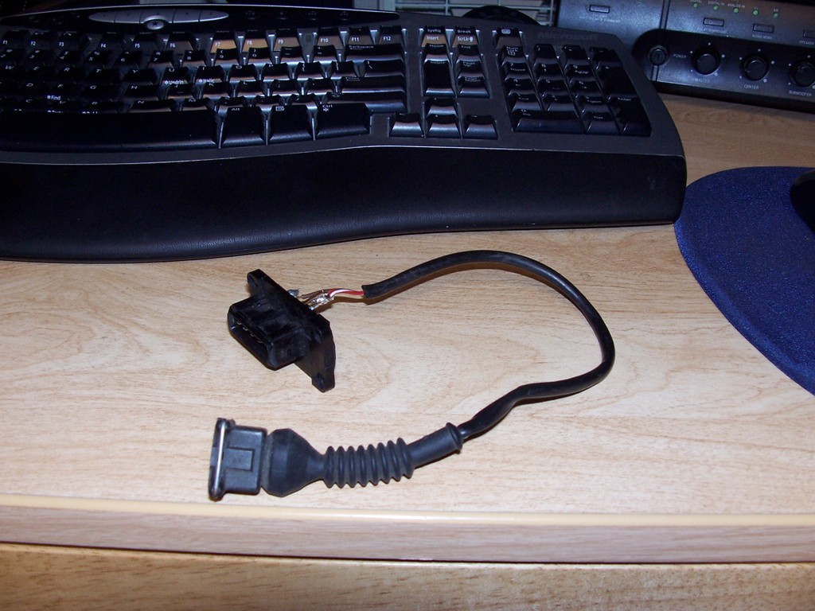
MAP
If you already removed the AFM you could use an external MAP sensor if you don't want to run a vacuum line to the ECU. Use the afm signal wires and share the ground with the IAT sensor. Run a signal line from the input pin on MS (varies with code) to pin 7 on the 55 pin and 5v from the proto area to pin 12
Signal is GRY/YEL
5v is GRY/WHT
GND is shared with IAT on GRY/BLU

***Either way though, you need to tap into the vacuum system of your car. Make sure it is a point after the throttle body. A good place is in the fuel pressure regulator vacuum line.
The same thing can be done with a MAF but only some codes of MS2 support it (not MS2extra) and MS1 extra. Check first
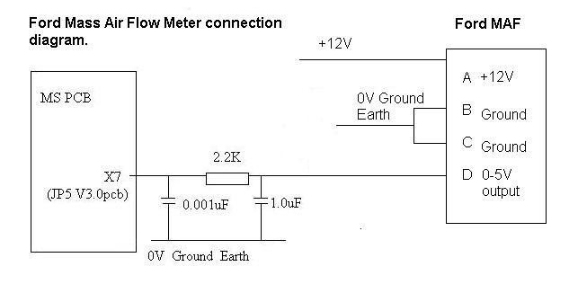
For the m20/30/88 series engines, you will also need a variable TPS. Though it is possible to run the car without i strongly recommend one. The m20/30 auto TPS will work but will need a pigtail for the connection. The S/M5x TPS will also work but will need an adapter plate to fit the TB. They are not hard to make.
The instructions for figuring out the pins for your TPS are in the Megamanual. I have quoted the paragraph below. The wire from an e34 535i stock harness are as follows:
BRN/ORG is GND
BRN/BLK is signal
BRN/BLU is 5v reference
***If you are using the M50 TPS, the stock connector can be used***
"MegaSquirt uses the throttle position sensor (TPS) to determine when the engine is at or near full throttle (to shut off feedback from the O2 sensor), when the engine throttle is opening or closing rapidly (and needing an accel/decel enrichment), and when the engine is flooded and needs to be cleared. Some people have managed to make their engines function reasonably well without a TPS. This is not recommended with the standard code, however.
You will need a TPS that is really a potentiometer and not a switch. Many older cars had idle or WOT position switches instead of a real TPS. A real TPS gives a continuously varying signal with changing throttle. There are two wires on the external wiring schematic that go from MegaSquirt into the TPS sensor. These two MegaSquirt wires are +5 Vref signal and a sense line. There is a third wire going to ground. Assuming that you have a proper potentiometer TPS, then +5 Vref goes to one side of the pot, the other side goes to ground and the sensor line is hooked to the wiper.
To hook up your throttle position sensor (TPS), disconnect the TPS, and use a digital multi-meter. Switch it to measure resistance. The resistance between two of the connections will stay the same when the throttle is moved. Find those two - one will be the +5 Vref and the other a ground. The third is the sense wire to MegaSquirt. To figure out which wire is the +5 Vref and which is the ground, connect your meter to one of those two connections and the other to the TPS sense connection.
If you read a high resistance which gets lower as you open the throttle, then disconnected wire is the one which goes to ground, the other one which had the continuous resistance goes to the +5 Vref from the MegaSquirt, and the remaining wire is the TPS sense wire.
The throttle position sensor is used for flood clear mode and EGO enrichment, as well as accel enrichment" -From Megamanual
O2 sensor
As stated earlier, i highly recommend th LC-1. Place it in the stock sensor location and hack off the pigtail from your old sensor. If you ever want to go back to motronic, the LC-1 can simulate a narrow band.
Wire the LC-1 straight in to the pig tail and seal it with heat shrink
Pin 1- Sensor GND- GRY
Pin 2- Signal - BLK
Pin 3- GND- White
Pin 4- 12v- White
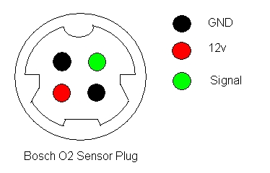
Use an ohm meter to determine which white wire to use for power
From LC-1
BLU and WHT are both GND- combine them with a spare black wire about 4 ft long and connect them to the GND wires on the Bosch connector
RED wire is power, connect it to the 12v white wire
BRN wire is output 1 and will go to the BLK wire
BLK wire is the calibration wire. Connect about 4 ft of RED wire to it
YLW wire is output 2. It can be used for a gauge or leave it there and tuck it in out of the way
The spare BLK and RED wires you attached are for the calibration button. Run them into the cabin of your car ( i ran them up through the shift boot and keep them hidden under the shifter. Connect the switch and LED to the two wires as outlined in the LC-1 manual. The Red wire on the LED connects to the RED wire you brought in. The switch won’t matter. If you want you could use any led and switch you want and make a nice mounting plate for in front of the shifter for other switches and gauges. I made a plate out of wood and put my launch control, LC-1 switch and LED, and a USB port for easy access and will add things as i go. It looks very nice.
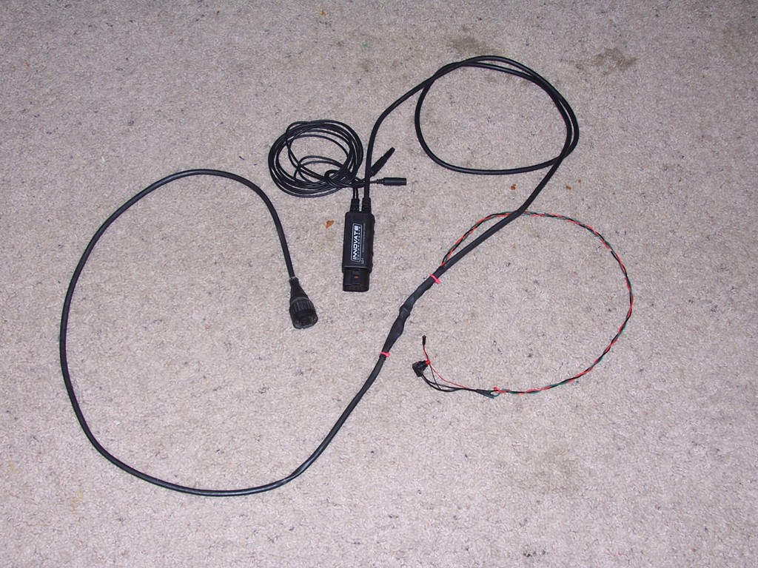
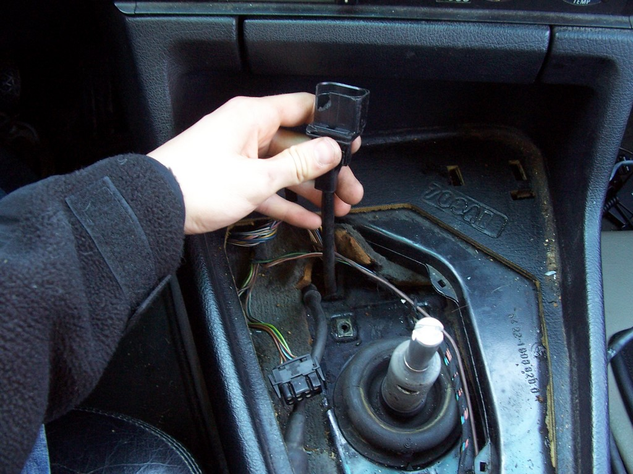
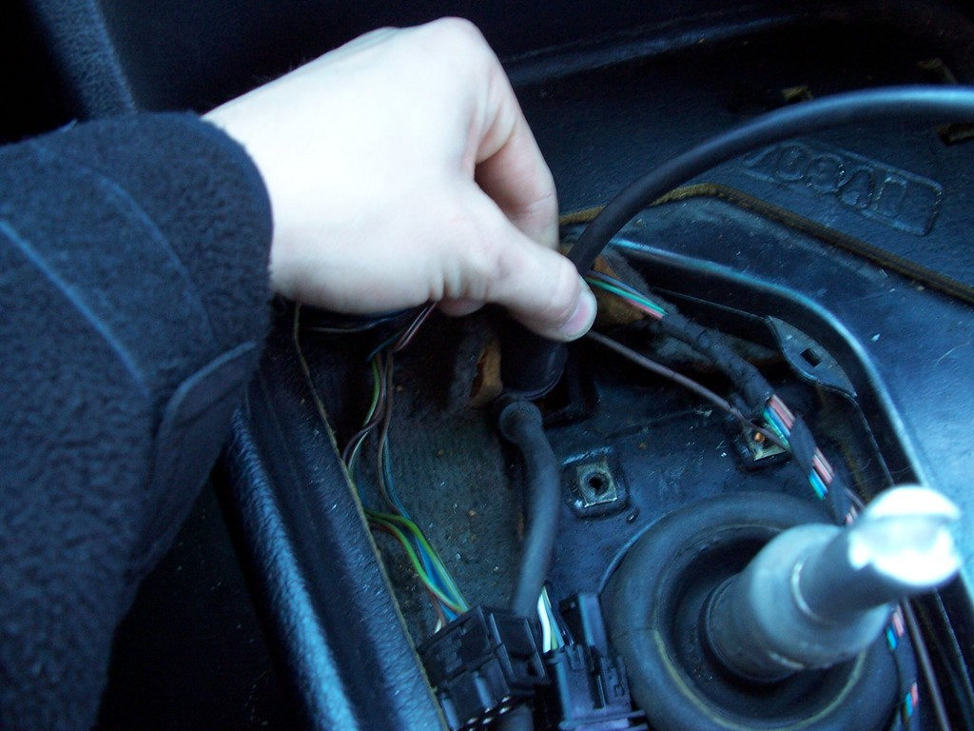
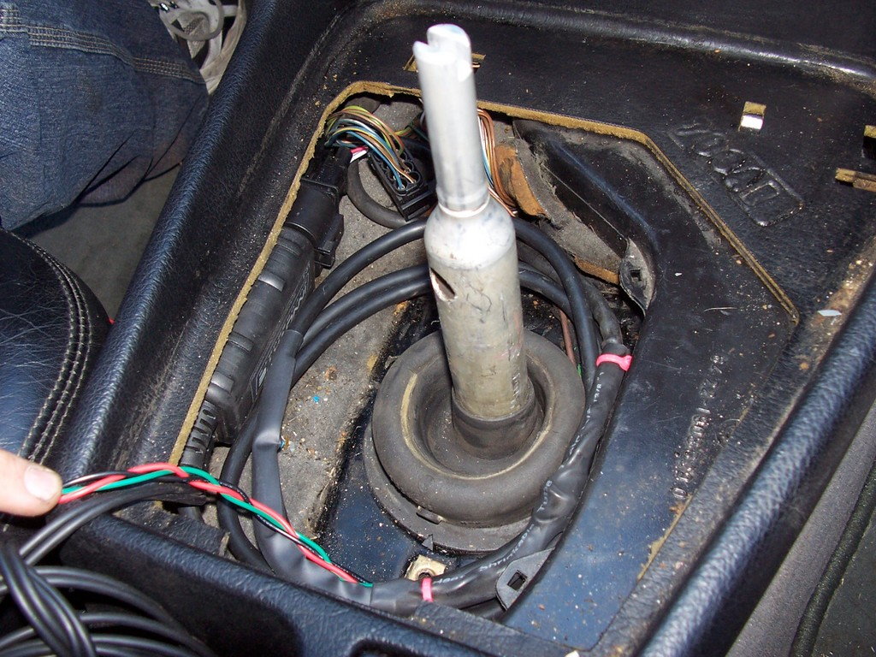

External Accessory Wiring

Here is a diagram for the accessory DB15 on the adapter board.

-The Ign wires are for wiring in wasted spark coils and if used the stock coil MUST be disconnected.
-The TPS wires are only for if you don’t want to cut your stock harness and want to use a non m50 tps.
-The Boost solenoid and relay activation circuit only may draw power from the 12v pins. They are not meant to power high current items like coils or electric fans.
-The switch pin is activated be grounding pin 1. Put a switch in line with a wire on pin one to ground.

For more info on how to use any of these features, please consult the MSextra hardware manuals.

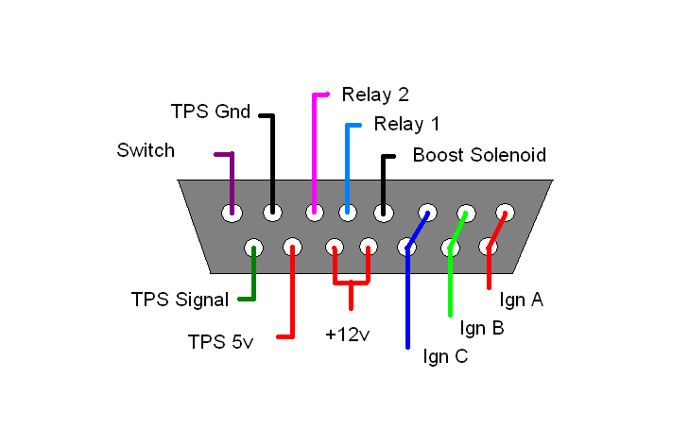

Other Notes- The stock BMW wiring harness provides the ign coil with power whenever the key is in position 2. For this reason, you should never leave the key in pos 2 for more than 5 seconds wit out the car running. Failure to do so could potentially destroy your vb921 coil driver or worse.

